Redcliffe Aero Club
INSTRUMENT RATING QUESTIONNAIRE

The purpose of this questionnaire is to ensure your knowledge is sufficient to pass the Instrument Rating Flight Test requirements. Your answers should be thorough and include sufficient detail to demonstrate your suitability for test recommendation by your Instructor. This document will also serve as a personal reference in the future when you are refreshing your knowledge.

Please write or type your answers on this document You may need to attach other documents to show working. Please also reference your answers (eg: RPL Privileges & Limitations. Ref: CASR Part-61.G.1)
Answer the questions with reference to the endorsements which are to be sought.

This questionnaire is based on flight test report form – CASA Form 61-1504 (amended) 09/2014.
Below is an extract from 61-1504. The form will be used by your Testing Officer to mark the outcomes of your IR Flight Test.

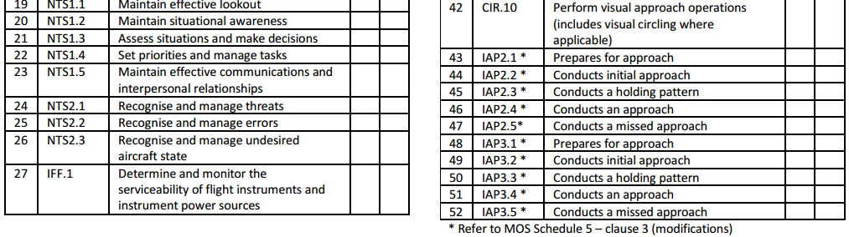
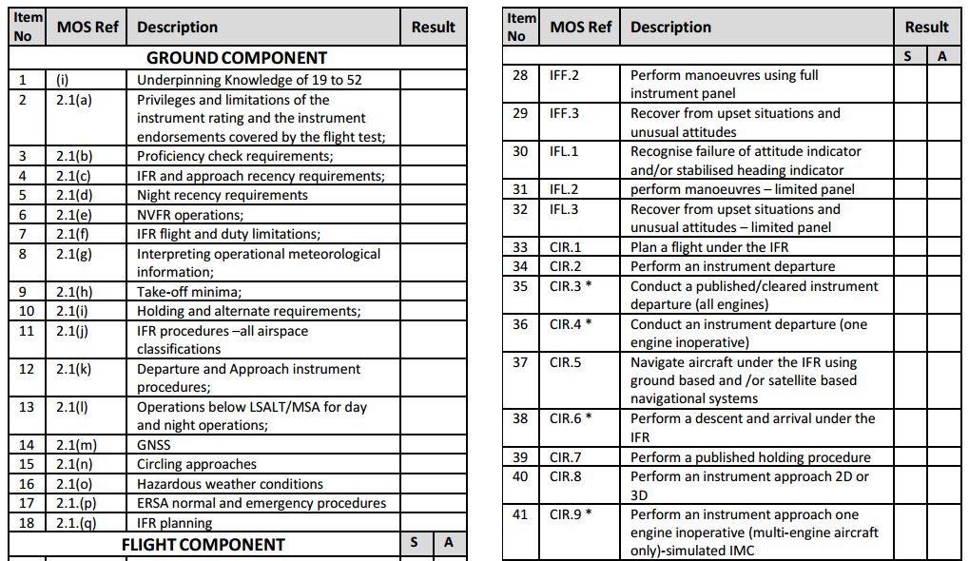
1. Underpinning knowledge required for items 19 to 52

- IMC can be defined as any condition outside of VMC criteria. Complete the following VMC diagrams:

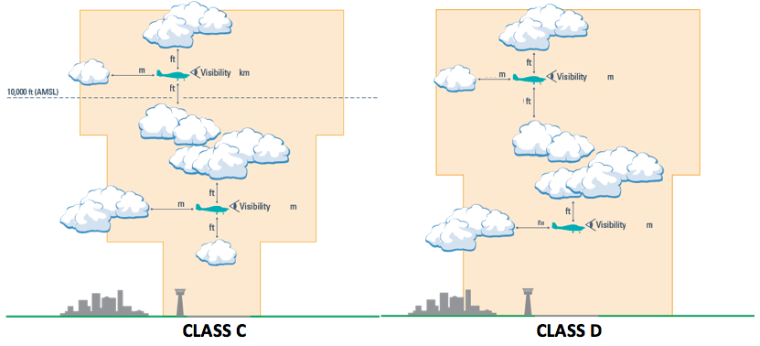
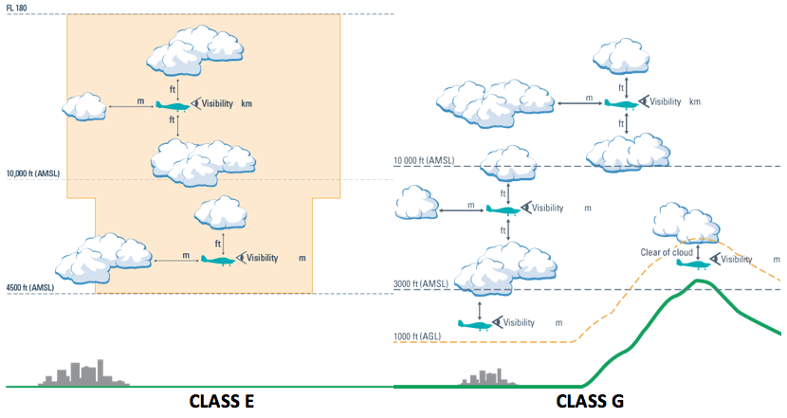

- List the instruments required for an IFR charter flight.

- List the required communication equipment for an IFR CHTR flight from Redcliffe (YRED) to Blackall (YBCK).

- A third attitude indicator is unserviceable. Your operator does not use MELs. Under what conditions may an IFR charter flight proceed.

- Refer to CAO 20.18 and AIP-GEN 1.5 & 1.6. Determine if you are required to have the following items for an IFR flight. Include any applicable conditions:

  - Transponder

  - Assigned Altitude Indicator

  - Auto Pilot

  - TCAS

  - GPWS

  - Weather radar

- List the required aircraft lighting systems (internal and external) for an IFR flight. Which lights are required for a day IFR charter?

- State the minimum number/types of navaids and radio communication devices for a IFR flight through CTA.

- List the transponder requirements for IFR operations in all airspace types

- How would you annotate the transponder fitted (as required) on your flight plan?

- Label the following chart symbols:

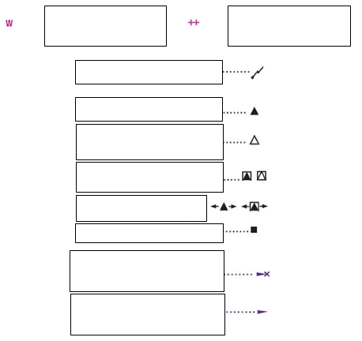

- List the minimum broadcasts you should make on a CTAF when arriving and departing IFR.

- What information must be included in an IFR departure report to ATC from a CTAF?

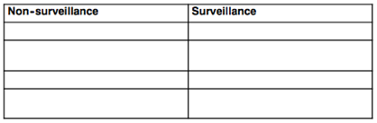

- What is the Glider VHF Frequency?

2. Privileges and limitations of the instrument rating and the endorsements covered by the flight test;

- List the privileges of an Instrument Rating. Consider: type of aircraft, type of operations, flight rules, day/night etc.

- You gain a job with a major airline thirteen months after your last instrument rating proficiency check. You are checked to line and are currently flying IFR in a multi-crew operation. Can you hire an aircraft from The Redcliffe Aero Club and fly under the IFR? Explain why/why not.

3. Proficiency check requirements;

- You hold an instrument rating with the endorsements which you have been trained for. How often must you conduct a proficiency check to continue using the privileges of your instrument rating?

4. Recency requirements;

- List all of the recency requirements for a single pilot IFR passenger carrying charter.

To conduct a 2D Approach

CASR 61.870(4)
INSTRUMENT RATING
SINGLE PILOT

CASR 61.860(2)

CASR 61.875
MULTI CREW

CASR 61.870(1)

PILOT IN COMMAND

CASR 61.870(2)

CASR 61.870(3)

To conduct an
azimuth approach

CASR 61.870(6)
To conduct a
CDI approach

CASR 61.870(7)

To conduct a 3D Approach

CASR 61.870(5)

To conduct a circling approach

CASR 61.860(3)

5. Night recency requirements;

- What are the recency requirements for a night IFR passenger carrying charter?

6. NVFR operations;
- What is the circling area for an IFR flight at night for a non-controlled aerodrome without a published instrument approach?

- What are the alternate requirements for lighting for an IFR flight?

7. IFR Flight and duty limitations;

8. Interpreting operational meteorological information;

Consider the following TAF: (Assume you are RNAV GNSS approach capable)
GOLD COAST (YBCG)  TAF YBCG 120409Z 1200/1300  28012KT CAVOK  FM120400 30015KT SCT020  FM120500 27015KT 8000 BKN020  INTER 1205/1207 27015G30KT 5000 BKN014  RMK FM121200 MOD TURB BLW 5000FT TILL 122100  T 17 12 11 10 Q 1010 1013 1014 1015  METAR YBCG 120400Z AUTO 28011KT 4000 // BKN009 17/M02 Q1010  RMK RF06.2/015.0 | a) What are the alternate minima for YBCG?  b) If you plan to arrive at 3pm, do you need an alternate? Explain your reasoning.  c) What is the forecast QNH and temperature for your planned arrival time?  d) In the METAR, what do the following mean?  - 17/M02  - //  - AUTO

- What are approved sources of QNH and how long is this information valid?

- When using area QNH, what correction should be applied to the minima?

- All DA must be adjusted to determine an Aerodrome Operating Minima (AOM). The corrections for pressure and temperature are...

9. Take-off minima;
- State the take-off minima for your aircraft in terms of altitude and visibility.

- Despite the take-off minima in the previous question, what are your obligations after takeoff regarding terrain clearance and performance?

- You are flying from Merimbula (YMER) to Albury (YMAY). Write a plan for an instrument departure (non-SID, with the following weather conditions) including normal and non-normal operations.

SPECI YMER 180119Z AUTO 17007KT 4800 // BKN010 OVC026 19/15 Q1023
RMK RF00.0/000.0

10. Holding and alternate requirements;
- List the reasons why Wondai might need an alternate for a flight at night commencing at Redcliffe. Use the “Alternates Could Very Well Prove Life Savers” mnemonic to ensure you cover all considerations.

- A terminal area forecast has a TEMPO period 0208. (a) Between what ETA’s do you have to carry holding fuel? (b) If your ETA was 0820, how much holding fuel should you carry, if any?

- List the holding/alternate requirements for an arrival at the following destinations.

a) Arrival at YBSU 1145 Local.

SUNSHINE COAST (YBSU)
TAF AMD YBSU 122216Z 1300/1312
06012KT 9999 SHOWERS OF LIGHT RAIN SCT015 BKN030 BKN050
TEMPO 1300/1302 2000 SHOWERS OF MODERATE RAIN BKN010
INTER 1302/1309 3000 SHOWERS OF MODERATE RAIN BKN012
RMK
T 27 28 27 25 Q 1008 1007 1006 1007

b) Arrival at YBBN 1100 Local.

BRISBANE (YBBN)
TAF AMD YBBN 121924Z 1219/1324
15006KT 9999 SHOWERS OF LIGHT RAIN FEW012 SCT025 BKN050
FM122300 06011KT 9999 SHOWERS OF LIGHT RAIN BKN020 BKN040
FM130800 02008KT 9999 SHOWERS OF LIGHT RAIN SCT020 BKN035
FM131400 35008KT 9999 SCT020 BKN050
INTER 1219/1221 3000 SHOWERS OF MODERATE RAIN SCT006 BKN010
TEMPO 1221/1302 2000 SHOWERS OF MODERATE RAIN SCT006 BKN010
INTER 1302/1305 3000 SHOWERS OF MODERATE RAIN BKN012
RMK
T 23 25 26 26 Q 1008 1009 1008 1006

TTF SPECI YBBN 122300Z 03008KT 9999 SHOWERS OF LIGHT RAIN FEW005
SCT010 BKN050 25/24
Q1009
RMK RF00.0/005.8 CLEARING
FM2310 06011KT 9999 SHOWERS OF LIGHT RAIN BKN020 BKN040
TEMPO 2300/0200 2000 SHOWERS OF MODERATE RAIN SCT006 BKN010

SPECI YBBN 122300Z 03008KT 9999 SHOWERS OF LIGHT RAIN FEW005 SCT010
BKN050 25/24
Q1009
RMK RF00.0/005.8 CLEARING

ATIS YBBN F 122235
APCH: EXP INSTRUMENT APCH
+ RWY: 01
SFC COND: WET
OPR INFO: HIAL ON
+ WIND: 060/8
+ VIS: GT 10 KM, REDUCING TO 4000M IN SHRA
CLD: FEW005, SCT008, BKN016
TMP: 24
QNH: 1009

11. IFR procedures – all airspace classifications;
- You’re enroute OCTA and Centre advises that due to traffic, you should commence a holding pattern at your next waypoint. Your inbound track is 085°M and the waypoint is BURCH. Sketch an accurate diagram of a standard holding pattern at BURCH. Include the sector entry divisions. Include the tracks for the SE divisions and each leg of the holding pattern.

12. Departure and approach instrument procedures;
- You are conducting the Canberra Nine Departure (RWY 12). The current conditions are:

TTF METAR YSCB 240400Z 03010KT 4000 BKN008 28/27 Q1009
RMK RF03.0/010.0
NOSIG

Considering a MTOW departure in your test aircraft:
- Determine if your aircraft performance (normal and asymmetric) meets the SID obstacle clearance requirements.
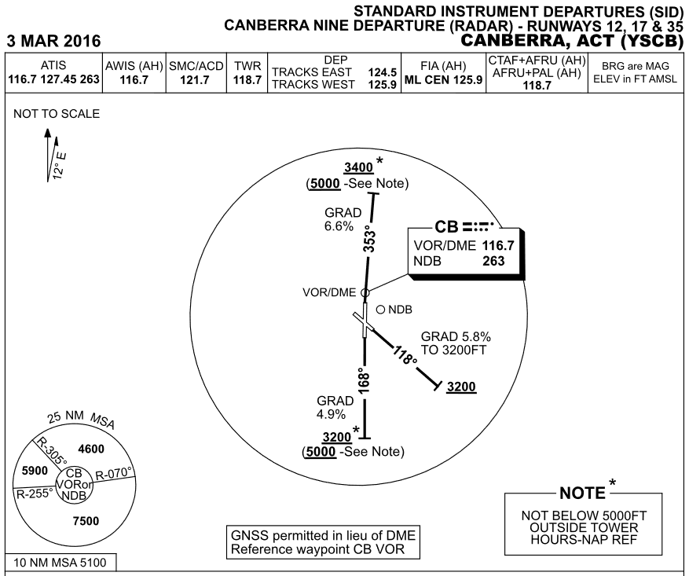
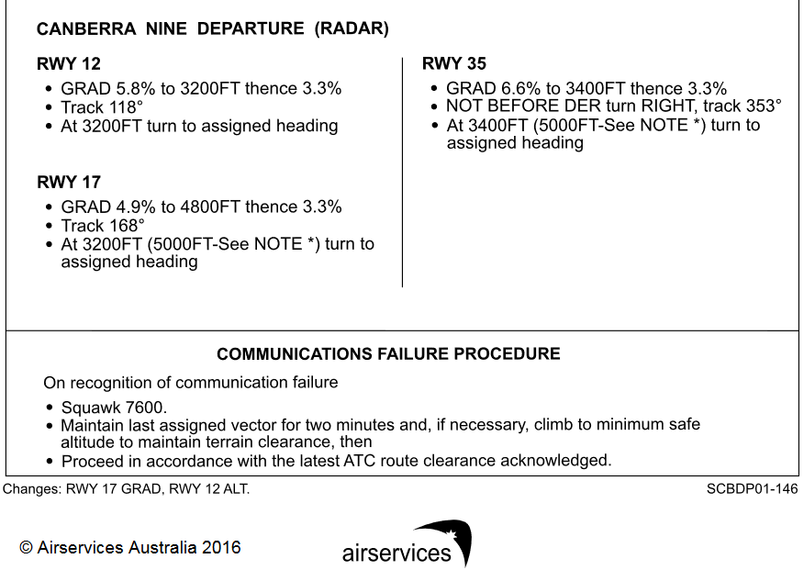
- Describe your plan in the event of an engine failure on the SID in IMC.

13. Operations below the LSALT/MSA for day and night operations;
- List the times and conditions by which you can be below your LSALT.

  - ______________________________

  - ______________________________

  - ______________________________

  - ______________________________

  - ______________________________

- When operating under the IFR below the LSALT and not endorsed for instrument approaches, what are the minimum visibility and clear-of-cloud requirements?

- State the conditions that must exist for a pilot to conduct a visual approach into an aerodrome by day.

- How do the visual approach requirements change by night?

- You’re departing from Kingaroy with an enroute LSALT of 4700ft. The cloud is OVC028. Describe how you will conduct your departure. Sketch your planned departure track on the chart provided.

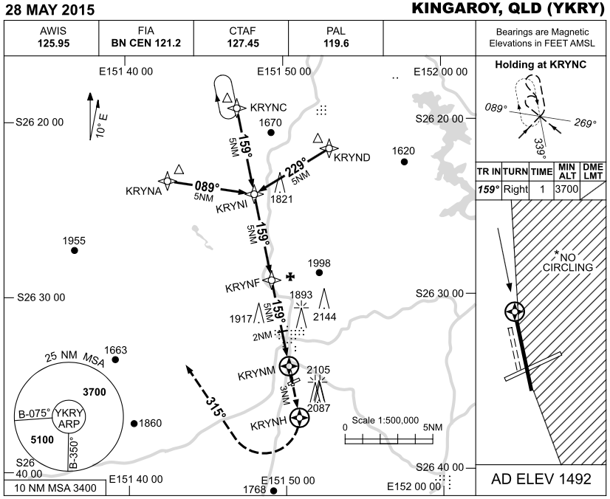
14. GNSS;

- List the errors of GPS (a GNSS).

SYSTEM ERRORS

  - ______________________________

  - ______________________________

  - ______________________________

  - ______________________________

  - ______________________________

  - ______________________________

  - ______________________________

FLIGHT ERRORS

- What frequency band does GPS work on?

- What is PBN and RNP? Draw the RNP standards on the following diagram.

25NM

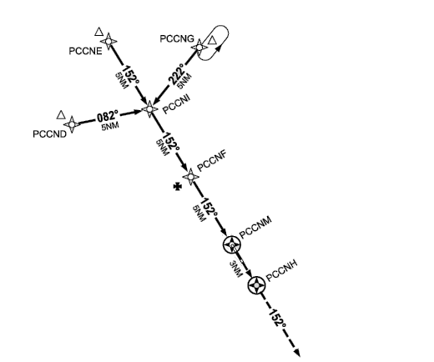

- What is the tracking tolerance when tracking via an area based navigation system (GNSS)?

- How and when should GPS computed flight plan position and tracking information be checked for reasonableness?

- Can a user entered waypoint be used for tracking under the IFR? What are the restrictions or requirements?

- What is the minimum GPS TSO requirement for IFR area navigation?

- What is the difference between a C129, C145 and C196 receiver?

- How do you identify what type (TSO) of receiver is fitted to your aircraft?

15. Circling approaches (only complete if applicable);
- After conducting an IAL to the circling MDA and becoming visual, you must not descend below the circling MDA unless: (list the AIP requirements)

  - ______________________________

  - ______________________________

  - ______________________________

  - ______________________________

  - ______________________________

- You are conducting the NDB-A for RWY 18 at YBSU (circling minima only). Can you join final and fly straight-in to land after becoming visual? Explain your reasoning. Refer: CAAP 178-1(2).

- Define the circling area for the following:

 | CAT-A | CAT-B
YRED day
YRED night
YBCG day

16. Hazardous weather conditions;

- Label the type of icing conditions in the following cloud formations:
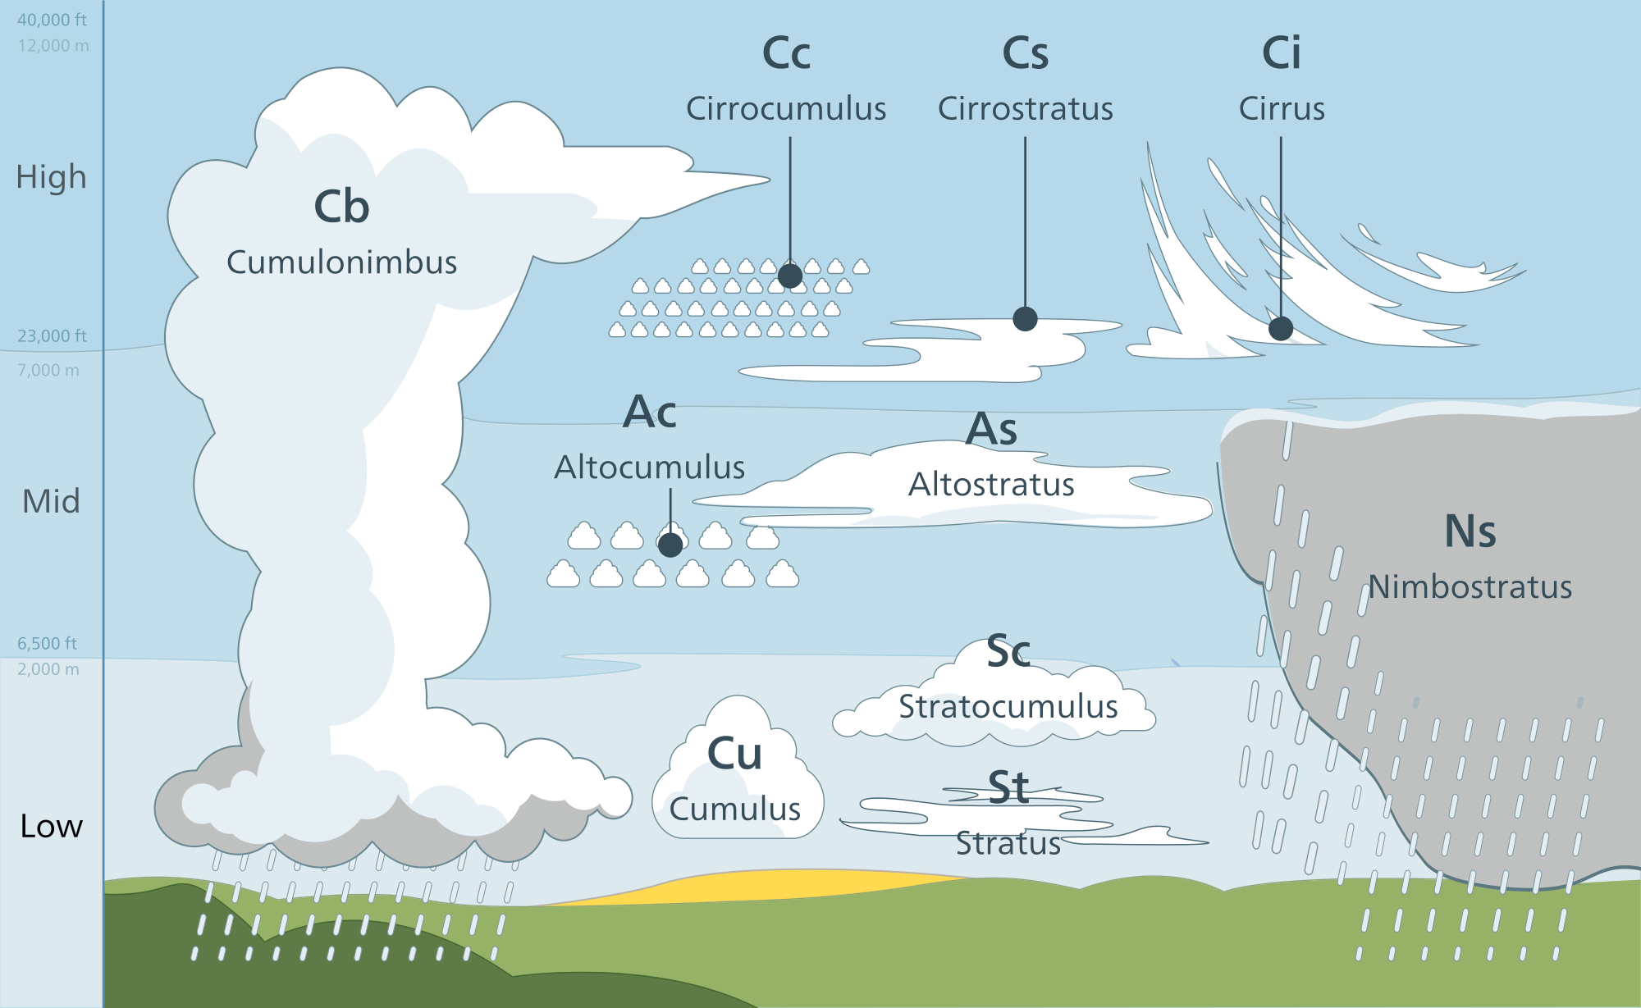

- List your actions if ice was to form on an aircraft that was not fitted with ice protection.

- Label the lifecycle of a thunderstorm and associated hazards.
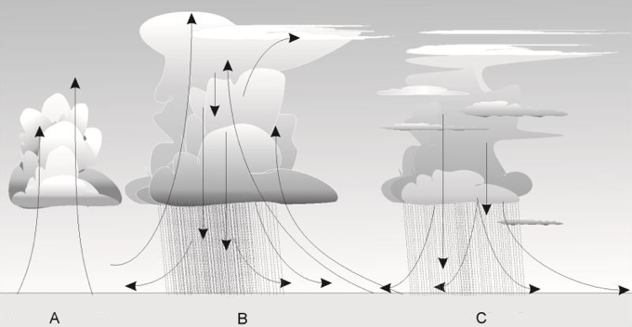
LIFECYCLE

A

B

C

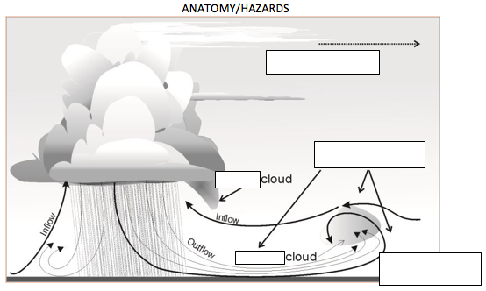

17. ERSA normal and emergency procedures;
- What would you do in the event of a radio failure at night in IMC, during descent to a radar lowest safe of 3000 feet for Redcliffe, in CTA?

- Describe the method of activation for a PAL lighting system and a AFRU-PAL lighting system. At what distance would you activate the PAL when inbound to an aerodrome?

- List the available lighting for each runway at the Gold Coast. Outside of Tower hours, how would you activate the T-VASIS? With reference to the T-VASIS system, what does “3.0DEG39FT” mean?

18. IFR Planning
- Can an aircraft fitted with no anti-ice or de-icing equipment plan to fly above the freezing level?

- A. List the methods of calculating a LSALT for an IFR flight.

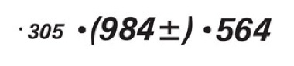
B. What is the difference between the following chart symbols?

C. Calculate the LSALT and label the method of LSALT calculation on the charts below:
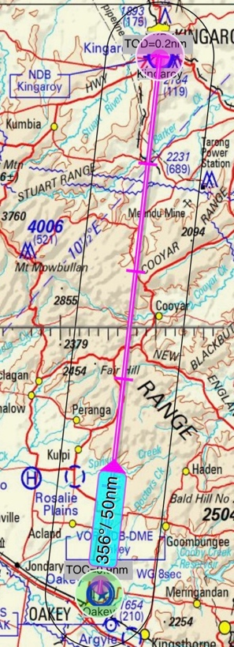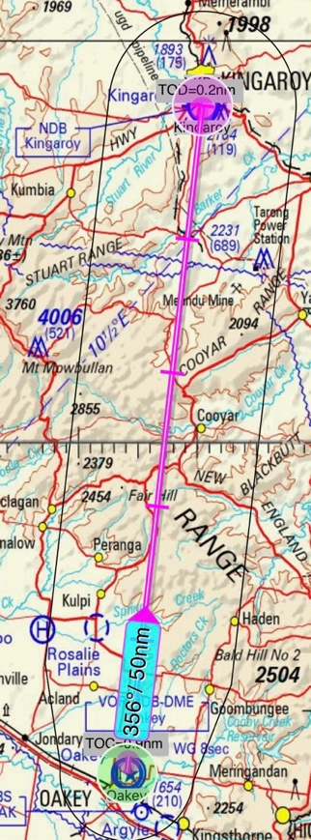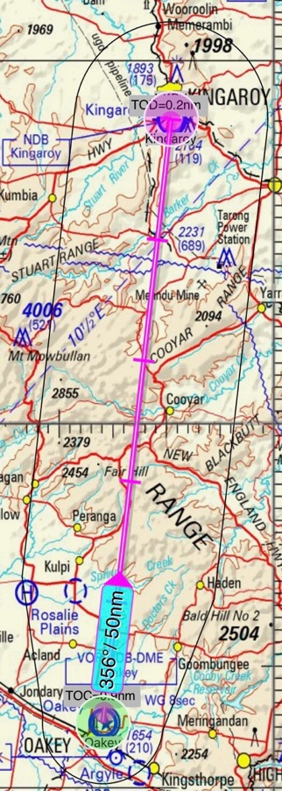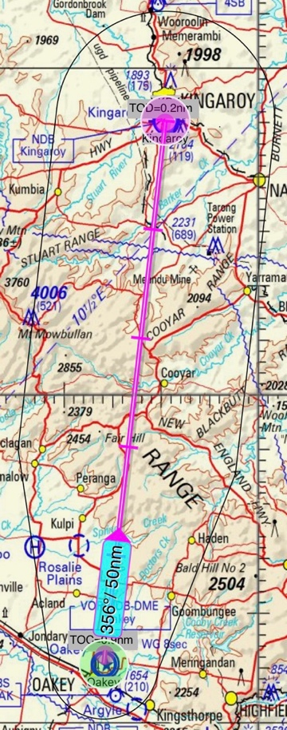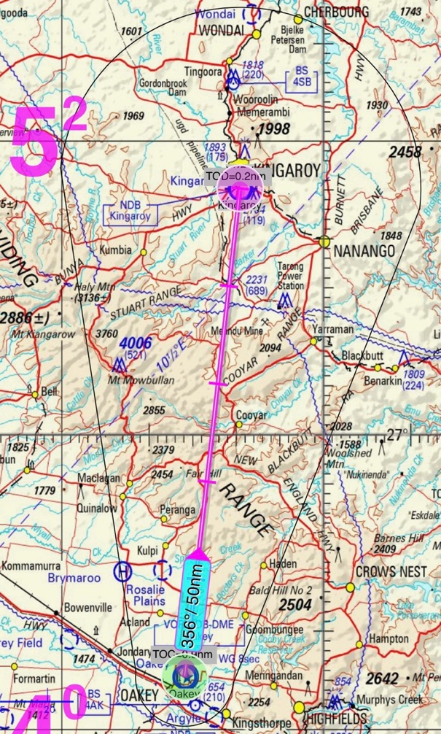

RNAV (GNSS) approach (only complete if applicable);

- List the situations where you must execute a missed approach.

  - ______________________________

  - ______________________________

  - ______________________________

  - ______________________________

  - ______________________________

- What is the difference between the waypoints depicted below?

- Label the following on the two diagrams below.
  - GNSS (RNAV) Capture regions.
  - Stages of the approach (Initial, Intermediate, Final).
  - The speed restrictions applicable to each stage of the approach for a CAT-B aircraft.

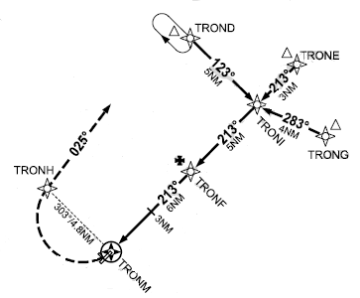

- Refer AIP-GEN 1.5 Paragraph 8. What are the required checks prior to an IFR flight during which you expect to conduct a GNSS (RNAV) approach?

- You are submitting an IFR Flight plan. You will be navigating with reference to the GNSS receiver and conducting a GNSS (RNAV) approach. How would you annotate this on the flight notification?

