Redcliffe Aero Club
MULTI-ENGINE AEROPLANE CLASS RATING QUESTIONNAIRE

The purpose of this questionnaire is to ensure your knowledge is sufficient to meet the MEA Class Rating Flight Test requirements. Your answers should be thorough and include sufficient detail to demonstrate your suitability for test recommendation by your Instructor. This document will also serve as a personal reference in the future, when you are refreshing your knowledge.

You will need to attach other documents to show working.
Please reference your answers as applicable (eg: CPL Privileges & Limitations. Ref: CASR Part-61.i.570)

This questionnaire is based on flight test report form – CASA Form 61-1496 (amended) 09/2014.
Below is an extract from 61-1496. The form will be used by your Testing Officer to mark the outcomes of your MEA Class Rating Flight Test. Also, reference CASR 61.385 to understand your obligations regarding knowledge and ability in an aircraft of a particular type or class.
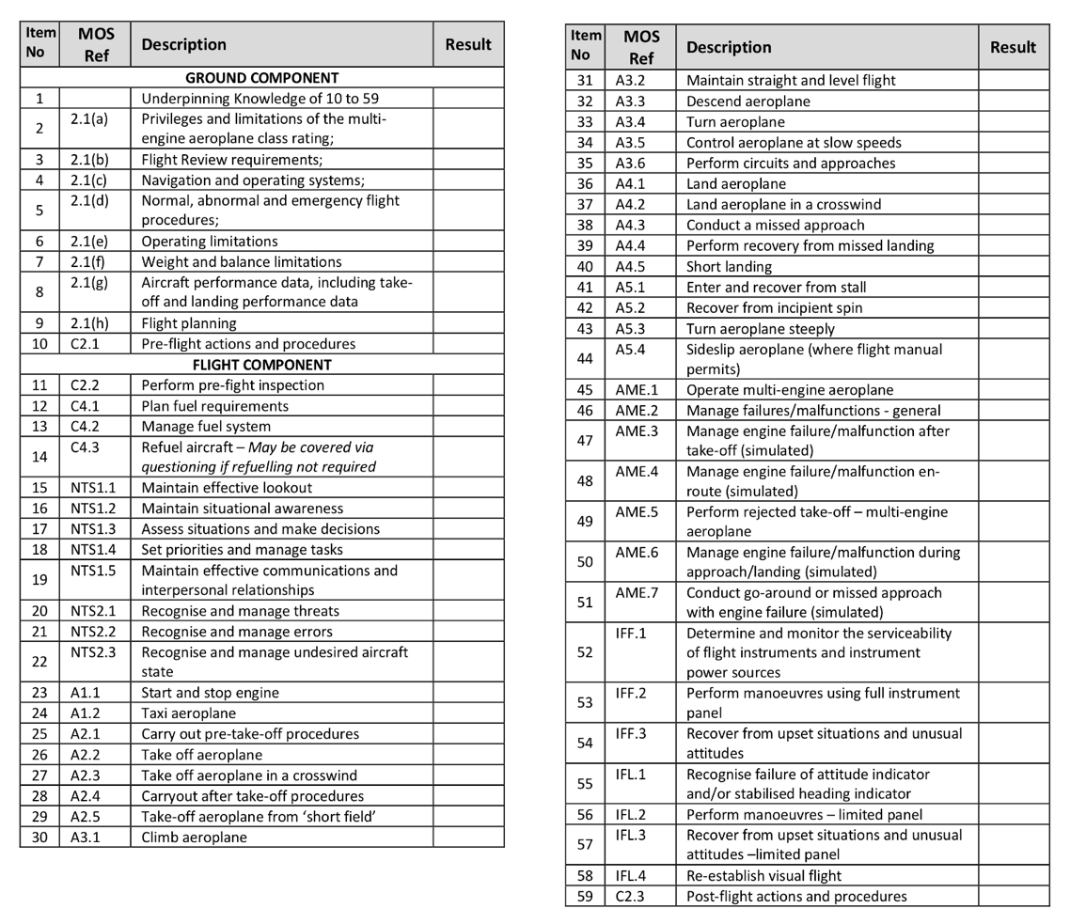

Underpinning knowledge for items 10 to 59
- What is the make, type and model of your test aircraft? In which category (categories) is it permitted to fly?
- Complete the following ‘Engine systems’ questions:
  - What is the make/model of the engines?
  - What is the power output, and number of cylinders?
  - What is the take-off power setting and time limit?
  - What is the maximum continuous power?
  - Are the engines supercharged of turbo-charged?
  - What is the maximum MAP permitted?
  - Describe the propeller governing system; and
  - If the oil pressure to the propeller dome is lost, does the propeller go into coarse or fine pitch?

- Complete the following ‘Fuel systems’ questions:
  - Do the engines have a carburettor or fuel injection system?
  - Describe the priming system and its use.
  - Where the fuel boost/auxiliary pumps are located and when are they used?
  - Are the pumps electrical or mechanical?
  - State the maximum and minimum fuel operating pressure.
  - Describe the fuel tank change procedure.
  - what conditions apply to tank selection for take-off and landing?
  - When refueling to less than full tanks, what restrictions apply? How is the fuel quantity checked?
  - Describe how you would feed both engines from the left tank using the cross-feed system.

- Complete the following ‘Fluid systems’ questions:
  - Describe if applicable, the minimum and normal hydraulic fluid capacity
  - State the correct grade of oil for the aeroplane
  - What is the minimum and maximum oil quantity before flight?
  - State the maximum, minimum and normal engine oil pressures
  - State the maximum, minimum and normal engine oil temperatures

- Label the aircraft with the following: Fuel tank filler points, fuel drain points, Oil dipstick locations, external lighting fixtures, pitot tubes, tie down points, emergency exits, fuel tank vents, fuel tank overflows.

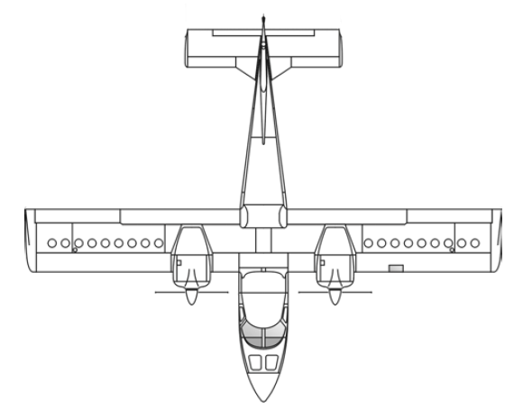

- Define Vmca in your own words. List the configurations used when determining an aircraft’s Vmca during certification.
- Complete the following ‘Asymmetric operations’ questions:
  - What effect will full flap have on VMCA?
  - What is the fuel flow rate with one engine shut down at 1000ft AMSL on an ISA day?
  - What is the rate of climb with one engine shut down, propeller feathered, MTOW, 2000ft AMSL, take-off power, flap retracted, on an ISA+10 day? What about an ISA+20 day?
  - Which engine is the critical engine?
  - How does single engine flight affect the range of the aeroplane?
- What is the asymmetric drift down, given the scenario (c) above?

2.1(a) Privileges and limitations of the multi-engine aeroplane class rating
- List the privileges of the MEA class rating.
- Refer CAO 82.1. Your multi engine logbook experience is as follows: PIC 2.8hrs, Dual 25.5hrs. Your company will shortly train you onto the Baron. What experience do you require prior to commencing VFR charter ops?
- Your company has a Cessna 441 on line which you’ll soon be training onto. Does the MEA Class rating cover this aircraft? What other endorsements may be required?
- You’ve previously gained a night VFR rating. After completing the flight test for the MEA Class Rating, can you combine these privileges to fly night VFR MEA?
- Can you fly night VFR charter in a MEA if you hold a night VFR Rating?

2.1(b) Flight Review Requirements
- You passed the flight test for the MEA Class Rating on 12/12/2018. When does your MEA FR expire?
- Does conducting a MEA flight review also meet the requirements of a SEA flight review?

2.1(c) Navigation and operating systems
- List the on-board navigation equipment for your aircraft. For GNSS, also state the TSO standard.
- Complete the following ‘Flight Instrument’ questions:
  - Is there a pitot heat system fitted?
  - Is there an alternate static source fitted? - if so: where is this located?
  - if used, what effect does it have on the pressure instruments?
  - Which flight instruments are operated electrically?
  - Which flight instruments are gyroscopically operated?
  - Which instruments are operated by vacuum?

- Complete the following ‘Ancillary Systems’ questions:
  - What systems are hydraulically operated?
  - What procedures are followed when a hydraulic system failure is suspected?
  - What are the sources of electrical power?
  - What is the DC system voltage?
  - Can an external power source be used? If so, what is the procedure?
  - Where are the battery and external power receptacle located?
  - How long can the battery supply emergency power?
  - Following an alternator/generator failure in flight, which non-essential electrical services should be switched off
  - Which, if any, ancillary system(s) will be lost if the left engine was shut down and the propeller feathered?
  - Which, if any, ancillary system(s) will be lost if the right engine was shut down and the propeller feathered?
  - If a stall warning device is fitted, is it electrical or mechanical?
  - How is the cockpit ventilated?
  - How is the cockpit heated?
  - State the location of the following safety equipment:
    - fire extinguisher
    - ELT
    - torches
    - survival equipment
    - first aid kit

2.1(d) Normal, abnormal and emergency flight procedures
- You suffer an engine failure enroute from YMDA to YCAB with 33nm to run. Referencing CAO 20.6, determine where you will land and justify your choice based on each of the CAO criteria (a) through (i).
- Detail the emergency procedures for the following situations:
  - engine fire on the ground
  - engine failure after take-off
  - engine fire airborne
  - engine failure in the cruise
  - electrical fire on the ground
  - electrical fire in flight
  - cabin fire in flight
  - the optimum glide speed for the aeroplane
  - propeller overspeed

- Complete the following ‘Normal flight procedures’ questions:
  - Describe the start sequence for cold and hot starts;
  - Describe the RPM used for checking:
    - the feathering system
    - minimum RPM for feathering
    - the ignition system
  - Describe the maximum RPM drop and RPM differential between magnetos when checking the ignition switches
  - Describe the use of cowl flaps (if fitted)
  - Describe the take-off power setting, IAS and fuel flow
  - Describe the cruise climb power setting, IAS and fuel flow
  - Extract a typical 65% power setting, IAS and fuel flow at 5000ft pressure height
  - Using the aeroplane flight manual, calculate the range and endurance for the aeroplane at 5000ft AMSL (ISA) with 65% power set
  - Describe how the mixtures are leaned in the cruise

2.1(e) Operating limitations
- List the applicable airspeeds for the aeroplane type:
Max X/Wind |  | Va |  | Vx
Vy |  | Vyse |  | Vsse
Vmca |  | Vne |  | Vno
Vfe 15° |  | Vfe 25° |  | Vfe 35°
Max + LF |  | Max Neg LF |  | Normal LDG
Vs0 |  | Vs1 |  | Short LDG

2.1(f) Weight and balance limitations
- Complete the following table:
Max Ramp Weight |  | Max Take-off Weight
Max Landing Weight |  | Max POB
Max Zero Fuel Weight |  | Max Baggage Weight

- Confirm that weight and balance is acceptable for the following scenarios. Attach a Loading Sheet and Weight & Balance Envelope for each question. If the weight or balance is outside of limits, propose a solution and attach the corrected W&B instead of the scenario W&B.

Pilot – 90kg | Passenger – 95kg | Passenger – 77kg | Passenger – 88kg
Fuel – 280L | Baggage – 60kg

Pilot – 80kg | Passenger – 70kg | Baggage – 35kg | Fuel – Full

2.1(g) Aircraft performance data, including take-off and landing performance data
- Using declared density charts, calculate the LDR and TODR for Springsure for a flight on the 23rd of January. Landing and Take-off weight will be approximately 1900kg.
- Using the TAF for Maryborough in the flight planning section, calculate the TODR at MTOW and the asymmetric climb performance once configured

2.1(h) Flight planning
- Attach a completed flight plan for the following route: Redcliffe – Mount Perry – Maryborough
Full stop landings at underlined locations. Use the attached Area 40 forecast and plan alternates as applicable. Use the Aircraft POH to determine Time/Fuel/Distance to climb and include this in your fuel plan. From POH cruise data, use actual fuel burn rates and TAS for the altitude chosen and forecast temperature. Plan at approximately 65% MCP. YRED departure time for alternate planning is 0200 UTC. 15 minutes stop time at Mount Perry. Assume MTOW for TAS reasons. Don’t calculate W&B, TODR, LDR.

AREA40 (40)
AREA QNH 01/04
AREA 40: S OF YRLL/YSYC 1016,
REST 1013

AREA QNH 22/01
AREA 40: SW OF YBTR/YHBA 1017,
REST 1014

AREA FORECAST 282300 TO 291100 AREA 40.

OVERVIEW:
BROKEN LOW CLOUD E OF YINJ/YXTX, MOSTLY ABOUT RANGES, TILL 00Z.
ISOLATED THUNDERSTORMS E OF DAG/YDAY/MIE CHIEFLY MORE THAN 20NM
INLAND FROM 02Z. ISOLATED SHOWERS E OF YBRK/YMYB/YLIS AND DEVELOPING
E OF DAG/YDAY/MIE FROM 02Z. ISOLATED AREAS OF SMOKE, LOCALLY THICK
NEAR FIRES.

SUBDIVISIONS:
A: NE OF DAG/YGYM.
B: SW OF DAG/YGYM.

WIND:
2000 5000 7000 10000
A: 110/15 110/20 110/20 120/20 PS09
B: 070/15 090/15 100/15 120/15 PS08
REMARK:
WINDS AT 2000FT TENDING 5-10KT STRONGER AFTER 09Z.

CLOUD:
ISOL CB 5000/35000 AND ISOL TCU 5000/20000 E OF DAG/YDAY/MIE FROM
02Z.
BKN ST 1000/4000 E OF YINJ/YXTX TILL 00Z AND NEAR PRECIPITATION.
SCT ST 1500/4000 TILL 00Z.
SCT CU/SC 2500/8000 SEA/COAST [20NM INLAND], 4000/9000 INLAND,
TENDING BKN NEAR PRECIPITATION.

WEATHER:
TSRA, SHRA, FU, PO.

VISIBILITY:
1000M IN TSRA.
2000M IN THICK SMOKE.
3000M IN SHRA.
8KM IN SMOKE HAZE.

FREEZING LEVEL:
ABV10000FT.

ICING:
SEV IN CB AND TCU.

TURBULENCE:
SEV IN CB AND TCU.
MOD IN CU.
MOD IN THERMALS AND DUST DEVILS BLW 8000FT INLAND DURING DAYLIGHT
HOURS.

MARYBOROUGH (QLD) (YMYB)
TAF YMYB 290018Z 2902/2914
11014KT 9999 SHOWERS OF LIGHT RAIN SCT025
FM291000 15005KT 9999 NSW SCT020
RMK
T 31 31 28 25 Q 1015 1014 1015 1016

TAF YMYB 281834Z 2820/2908
18004KT 9999 SCT025
FM290000 11012KT 9999 FEW045
FM290300 11014KT 9999 SHOWERS OF LIGHT RAIN SCT025
RMK
T 20 28 31 28 Q 1015 1015 1015 1014

METAR YMYB 290030Z AUTO 11010KT 9999 // SCT044 BKN058 31/19 Q1015
RMK RF00.0/000.0

