Redcliffe Aero Club
PRIVATE PILOT LICENCE QUESTIONAIRE

The purpose of this questionnaire is to ensure your knowledge is sufficient to meet the PPL Flight Test requirements. Your answers should be thorough and include sufficient detail to demonstrate your suitability for test recommendation by your Instructor. This document will also serve as a personal reference in the future, when you are refreshing your knowledge.

You will need to attach other documents to show working.
Please reference your answers (eg: PPL Privileges & Limitations. Ref: CASR Part-61.380)

This questionnaire is based on flight test report form – CASA Form 61-1488 (amended) 09/2014.
Below is an extract from 61-1488. The form will be used by your Testing Officer to mark the outcomes of your PPL Flight Test.

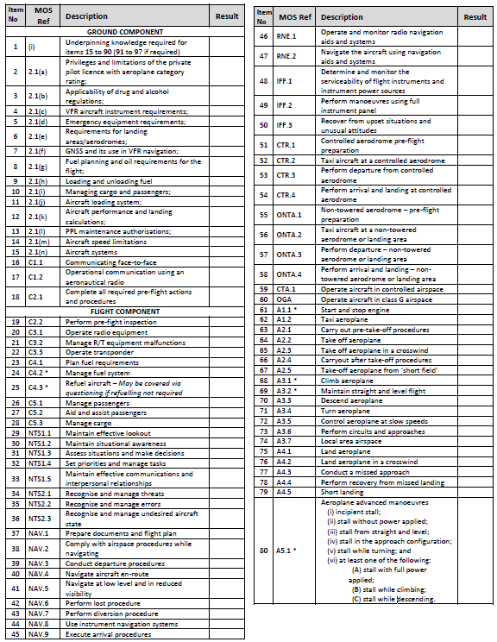
Underpinning knowledge required for items 15 to 90
- C1.2 When must the pilot in command test the radio apparatus and how is the radio tested?
- C2.1 What documents are required to be carried on board the aircraft?
- C2.2 What is the minimum oil quantity required for engine operation in the Cessna 172S?
- C2.2 What is the quantity of useable fuel (in litres) when the fuel tanks are filled to the bottom of the filler indicator tab?
- How many 80Kg passengers can be carried with fuel to the bottom of the filler indicator tabs in a Cessna 172 with the following basic empty weight?

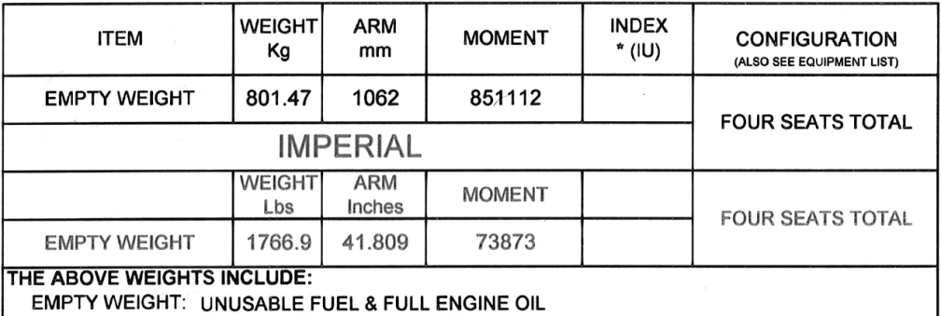

- C4.1 What is the minimum fuel required for a one hour flight in a Cessna 172S?
- C2.2/4.2 When are you required to check the fuel quality and what should your actions be if you find water contamination?
- C4.3 What precautions should you take prior to refuelling your aircraft?
- C4.3 Another aircraft is parked at the fuel bowser and is being refuelled. How close can you park to this aircraft? How would you judge this distance?
- C5.1 What are the minimum items that must be briefed to passengers prior to embarking the aircraft?
- C5.2 One of your two passengers is un-able to walk. Which seat would you allocate to this passenger?
- A3.7 Attach a map showing the training area boundaries and altitude limitations.
- A6.1 What is the ditching procedure listed in the Cessna 172S Pilot Operating Handbook?
- A6.5 What would your actions be in the event of an electrical fire underneath the instrument panel?
- IFF.1 The vacuum gauge indicates a low reading (outside of the green arc) during the engine run-up. List the instruments that will be affected.
- IFF.2 What is VMC? List the VMC (clear of cloud and visibility) requirements in class G airspace.
- IFF.2 What is the procedure if you inadvertently enter cloud?
- A2.2/4.5 Calculate the density height at Redcliffe, given a QNH of 1008hPa and a temperature of 32ºC
- A6.5 State the indications of a failed alternator. What steps can be taken to bring the alternator back on line?
- A6.5 What indications would you get from the flight and engine instruments if the master switch was turned off during flight?

2.1(a) Privileges and limitations of the private pilot licence with aeroplane category rating
- What does a PPL authorise you to do?
- What are the recency requirements of a PPL? What recency requirements relate to the carriage of passengers?
- Where may an PPL holder fly?
- What recency requirements relate to the carriage of passengers?

2.1(b) Applicability of drug and alcohol regulations
- What limitations apply with regards to alcohol consumption and flying as a Pilot?
- Is it safe to operate as pilot in command while taking prescription drugs?
- What types of drugs could impair your ability to safely operate an aeroplane?
- State what restrictions you as a pilot have with relation to alcohol consumption
- State the CASA regulations regarding smoking in aircraft. State R.A.C’s policy on smoking in aircraft.

2.1(c) VFR Aircraft Instrument Requirements
- CASA’s CAO 20.18 lists the minimum instrumentation for VFR private operations. The Cessna 172 POH Section 6 Equipment List states the minimum required instruments and equipment for flight in a C172S.
  - List the minimum instruments required to be serviceable for any private VFR flight.
  - If the ammeter was unserviceable, is it okay to fly a C172S?
  - If the tachometer was unserviceable, is it okay to fly a C172S?
  - If the Directional Gyro was unserviceable, is it okay to fly a C172S?

2.1(d) Emergency Equipment Requirements
- Where is the fire extinguisher located in the Cessna 172S and how would you check its serviceability?
- When must you carry life jackets?
- When must you wear life jackets?
- Where is the ELT located and how is it activated?

2.1(e) Fuel planning and oil requirements for the flight
- Determine the maximum amount of fuel that can be carried in your aircraft with the passenger load shown below. Plot both the Take-off weight (likely MTOW) and Zero Fuel Weight onto a loading envelope and attach it to this printed document.
Empty Weight/Moment | 801.47Kg / 851112 Kg/mm
Row 1 | 70kg Pilot | 80kg PAX
Row 2 | 55kg Pax | 65kg PAX
Baggage | 10kg
Fuel | ?

- What is the difference between ashless dispersant and mineral oil and for what purpose is each used?
- Describe how and why the mixture is leaned in the cruise.
2.1(f) Managing cargo and passengers
- What is the maximum amount of passengers that you can carry in a Cessna 172S? Consider rules regarding carriage of children.
- What is the maximum payload for Baggage Area A&B (Cessna 172S)?
- Can cargo be placed on the seats in Row 2? If so, are there any restrictions?

2.1(g) Aircraft Speed Limitations
- Complete the following table of speeds for the Cessna 172S:
 | Name | Speed (Knots Indicated Airspeed)
 |  | 2550LBS / 1156KG | 2200LBS / 998KG | 1900LBS / 862KG
V_{NE} | Never Exceed Speed | 163
V_{NO}
V_{A}
V_{FE}
V_{AT}
V_{TOSS}
V_{X}
V_{Y}
V_{S1}
V_{S0}
V_{MD}
Maximum Demonstrated Crosswind Velocity

- What is the acceptable static RPM range for the Cessna 172S and when/why is this checked?
- By what percentage does the stall speed increase in a 60º angle of bank turn?
- Calculate the take-off and landing distance required for your aircraft for the following 2 scenarios. Attach documents as required to showing your working:
 |  | Scenario 1 | Scenario 2
Pressure Height | MSL |  | 1500ft
Temperature | 30°C |  | 25°C
Surface | Sealed |  | Grass
Wind | Nil |  | 5kt Headwind
Weight | MTOW |  | 1100kg

